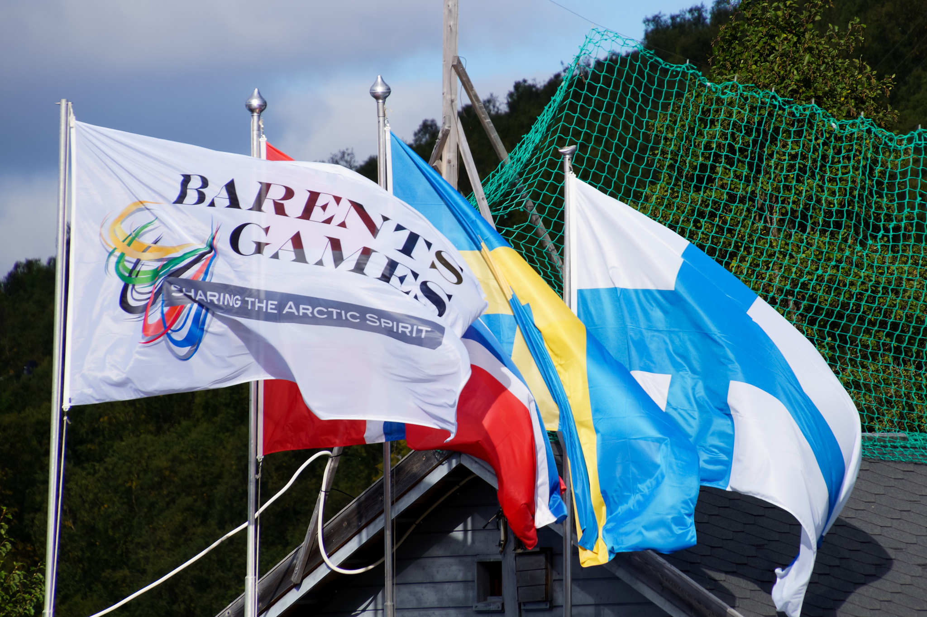  Event Manual  Barents Games | Summary  This event manual serves as a guide for the event organization, covering essential aspects from planning to execution, evaluation, and recommendations for future games.  Arntsen, Vera

Innhold
Introduction 3
Purpose 3
History and Background 3
Scope 3
Aims 3
Guidelines for application and coopteration 4
Organization 4
Organizational Structure 4
Partners 5
International Coordination 6
Timeline and dates 6
Timeline 6
Progress plan 8
Schedule Barents Games 10
Invitations 10
Programs 10
Participation 10
Participants 10
Volunteers 11
Sports, Rules, Regulations and Venues 11
Sports: 11
Sports Rules 11
Compliance 12
Disciplinary Measures 12
Venues 12
Venue Overview 12
Event Logistics 12
Opening and Closing Ceremonies 12
Food and Beverage 13
Transportation 13
Accommodation 13
Medals/Merge 13
Profile articles/print material 13
Young Leaders in Barents (YLIB) 13
Guests 13
Communication and Marketing 14
Information Sharing 14
Social Media and Media 14
Photo 14
Financial Management 15
Budget 15
Funding 15
Income statement 16
Evaluation and Reporting 16
Evaluation 16
Recommendations 16
Final report 16

Introduction

Purpose of the event manual
All organizers of the Barents Games must read this document thoroughly in the early stages of planning.
This document serves as the overall guidelines for all organizers of the Barents Games, covering every aspect of the event for all actors having a role in the planning or execution. There are local and regional differences in how to plan and carry out Barents Games depending on the country and organizer, but the Barents Games must be recognizable regardless of this. This is ensured by following the guidelines in this event manual.
We wish each Barents Games to be better than the last, and for the event to keep developing. Therefore, feedback on the document is given by the organizer to the international coordinator after the event.
Reading reports on previous events is recommended. These provide useful advice on and insight into how the Barents Games have been planned and carried out.

Background and purpose of the event
The Barents Summer Games is an international sports event for young people aged 15-25 years old from Finland, Sweden, and Norway, with Russia having participated in previous editions. The primary goal is to foster sports exchange, cultural understanding and personal growth among youth in the Barents region.
The Barents Games, established to strengthen regional ties through sports, have evolved over 70 years. The event has both summer and winter editions.
The event organizer, with all contributing partners, is guided by the Barents Sports Guidelines and the Barents Strategic Plan, revised every four years by the Barents Conference. Host cities are selected by the Barents Sports Committee (BSC), ensuring a rotation among member countries.

Legg til mer bakgrunn
Refer to the following:
Business idea: Develop friendship through sports in the Barents region
Vision: Sharing the arctic spirit
Values: Respect, friendship, honesty
The purpose of this Barents-cooperation in sports is not written down anywhere. What is the purpose?

Guidelines for application and cooperation
The owner of the Barents Games is the Barents Sports Committee and cooperates on all matters surrounding the announcement, awarding and follow-up of the event.
The awarding of each event takes place 3 - 4 years prior to the completion of the event and is awarded to a specific country (Norway (BSCN), Sweden (BSCS), or Finland (BSCF)).
When a country has been awarded the event, a request is sent to sports federations and regions in the country. Interested sports federations and regions enter into an agreement with their committee, which then makes the allocations.
There are various criteria for being allocated the event, such as arena access. Each Barents Games consist of up to 16 different sports. The timing of the event is set for week 12 - 14 for the Winter Games and week 34 - 36 for the Summer Games.

Organization
BSC gives the event to BSC(SNF), who passes the task of planning and executing the Barents Games to a regional sports organization in said country. The regional sports organization collaborates with local sports clubs, sports federations and sports regions to manage the competitions.
The international coordinator, based in Norway, is integral to the process, with clear delegation established well in advance. The coordinator is tasked with informing and gathering information about the national teams.
The organizer, being the regional sports organization, hires a project manager which is responsible for the planning and implementation of the event on a day-to-day-basis. The organizer and the project manager appoint a local organizing committee (LOC). The LOC assists the project manager according to allocated tasks. .
The BSC, the BSC(NSF), the international coordinator and the regional sports organization must all be continuously updated.
Local sports clubs are essential contributors, and their involvement are to be secured one and a half to one year before the event. Each sport has a dedicated club to manage its competition logistics, following guidelines set by the sports during Barents Sports Conference. Arranging clubs sets the specific schedules according to the guidelines given by the event organizer.

Organizational structure
Local Organizing Committee (LOC): The organizing committee is responsible for overseeing the planning and execution of the games. LOC need to Identify and assemble a team responsible for different areas
Key roles should include:
- Project Leader: Oversees the entire event’s planning and execution. Manages the budget and financial planning. Contact with sponsors and partners.
- Technical/Arena/clubs: Supervises sports, arenas and technical arrangements.
- Communication: Information and press, website and results service, invitation, registration, program.
- Volunteers: Recruits and coordinates volunteers.
- Transportation: Oversees internal transport logistics.
- Catering: Manages catering and meal arrangements.
- Accommodation: Manages the accommodation/hotels.
- Ceremonies: Responsible for the planning and execution of the Opening Ceremony and Get together
- YLIB: Responsible for the YLIB programme. Preferably a YLIBer from the host country.
- Guests: Responsible for the guest program. This can preferably be someone from BSC(S/N/F)
The entire organizing committee is responsible for first aid and safety within their areas.
Sports clubs play a big role in the organization of the event. Sports clubs should be asked to participate in the event already 1.5-1 year before the time of the event itself. Each sport must find its own sports club, which is responsible for the competition arrangements of the sport.
Barents local coordinators in Norway, Finland and Sweden are involved in the organization of the games. Contact information can be found on the Barents website. The International coordinator of BSC is located in Norway, which is involved in the organization of the games. The division of labor should be clarified well in advance of the event.
Country-specific sports coordinators gather their own country's teams for the event. Contact information can be found on the Barents website.
In previous years, Young Leaders in Barents, or YLIB, have participated in the competition arrangements. Previous tasks have included, for example:
• Hotel hosting and information
• Organizing the Get to Together event
• Social media and photography
• Planning the opening ceremony together with the competition team.
• Hosting the opening ceremony
Tasks are defined according to the interest and willingness of young people. They themselves get to express their wishes about the tasks they want to do. Young people work voluntarily.

Partners
- Public Authorities: Collaboration with municipal, regional, and national sports federations is essential and are key supporters.
- Sponsors and Partners: Funding and material support are provided by sponsors, local businesses, and additional stakeholders.

International coordination
International coordination involves maintaining communication with representatives from each participating country, ensuring compliance with international sports standards, and managing travel and regulatory requirements.

Timeline and dates

Timeline
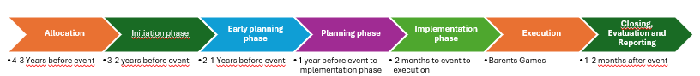
Allocation (3-4 years before event)
- Contact the sports federations and possible organizing sports clubs to check if there is a possible foundation for the event.
- Contact relevant authorities (municipalities, county municipality etc). to establish dialogue and partnership before the event.
- Check hotel capacity and arena capacity.
Initiation phase (2-3 years before event)
- Set up budget and funding: Estimate costs and assess funding sources (sponsors, grants, participation fees).
- Create a Timeline: Outline major milestones and deadlines leading up to the event date.
- Anchoring: Make agreements with the local sports clubs.
- Negotiation, anchoring and agreements with the local municipality, county municipality and the arranging clubs.
- Book arenas/venues.
- Negotiate good deals and book hotels.
- Make a good project description.
- Make a good presentation of the event for use in meetings with partners, conferences and board meetings. This also goes for coming phases of work and will need updates throughout the phases. The presentations shall always use the Barents Sports templets.
- Applications: To carry out the Barents Games, support from several state and regional partners is needed. Identify these and do the preparations and applications. This work follows also in the coming phases of work.
- Create new logo.
- Identify and contact potential sponsors and partners. Make good deals.

Early planning phase (1-2 years before event)
- Hire a project manager.
- Establish Local organization team (LOC): Assemble a core group with invested people for various areas (e.g. project leader, finance, communications).
- Check on the deals with hotels.
- Make a detailed project plan: Develop a comprehensive project plan covering all event aspects (sports, logistics, transportation, safety). Define work tasks.
- Negotiate and secure agreements with key partners, suppliers, and venues (including transport and catering).
- Continue work on applications (see initiation phase).
- Sign contracts with technical organizers (local clubs).
- Set deadlines for preliminary registration (around six months before the event).
- Set deadlines for registration. (two months before the event).
- Identify and contact potential sponsors and partners. Make good deals.

Planning phase 2 (1 year before event)
- Make final adjustments to the budget.
- Defining work tasks.
- Follow up all arenas/venues. Get confirmation and do inspections.
- Renew all agreements with hotels, transport, and catering.
- Ensure all necessary permits, transportation solutions, venue setup, and technical needs are arranged.
- Plan marketing campaigns, media outreach, and social media strategies to attract participants and the public.
- Hold meetings and close dialogue with the local clubs.
- Order medals.
- Order merch/gifts.
- Order rollups and other merch material.
- Order catering.
- Follow up sponsors and partners.
- Plan the ceremonies. Where, who, when, how?
- Make timetables for each competition.
- Prepare transport plan.
- Prepare guest program.
- Work on communication, web page and social media.

Implementation phase (2 months before event)
Put the project into practice: Create the best Barents Games ever.
- Detailed planning by the LOC.
- Check arenas.
- Finalize plan for result service, streaming and photo/film.
- Opening ceremony (detailed planning with production).
- Get Together (detailed planning with production).
- Communication (social media, media). How, what, who.
- Secure enough volunteers.
- Do something interesting with sponsors to start the event in a positive way.
- Last follow up of catering (lunch and dinner).
- Update web page.
- Prepare and finalize transport plan.
- Prepare and finalize guest program.
- Prepare and finalize YLIB-program.
- Prepare and finalize plan for result service, streaming, photo and film.
- Communication (social media, media).
- Decide where headquarters will be.
Execution
The implementation of the event is a large and hectic job, which requires both good planning and firefighting. If each phase of the planning is done well, this job will be much easier.
- See description of the event.
- Set up hotel hosts.
- Give out merch, flags and other equipment to the arranging clubs.
- Check in and welcome: Set up check in routines, information points, and reception for participants and guests.
- Set up and test the venue, transport connections, and technical equipment.
- Coordinate the opening ceremony, competitions, and any social events.
- Follow up with results sharing and updates on social media and websites.
- Host leader information meeting.
- Coordinate the teardown of venues, cleanup, and return of equipment.
- Ensure all participants and guests travel home safely.
- Host a closing event for arranging clubs, volunteers, and partners.

Progress plan
Creating a good progress plan is a success criterion for a good event. In the following is a proposal for a progress plan, but this will work out differently in the various committees.
Circuit, fighting, remove halls, remove punctuation marks, agreements/deals, Event the year before?, BG, sending, Volunteers, peakers, Guests, judges. Checking, packing,

Schedule Barents Games
The recemended schedule is as follows for the organizers of the event:
The event spans three days: Friday through Sunday.
The days before the event:
- Meeting with the arranging sports clubs.
- Distribution of equipment to arranging sports clubs.
- YLIB arrives on Wednesday before the event

Friday:
- Arrival in the host city for participants and guests.
- Optional competitions and testing of competition arenas.
- Leader/information meeting.
- Opening Ceremony.
- Start of the guest programme.

Saturday:
- Main competition day.
- Youth Get-Together event.
- Exclusive event for invited guests.

Sunday:
- Competition finals, additional training if competitions are completed.
- Guest programme concludes with a lunch.
- Departure between approximately 13:00 and 15:00 for guests and participants.
Arrangør skal være tilgjengelig både før og etter arrangement – skriv noe om det.

Invitations
Vedlegg

Programs

Participation

Participants
Eligibility Criteria: Participants must be aged 15-25 and meet specific qualifications related to their sport. Each country’s sports federations will provide detailed eligibility criteria.
Registration: Registration involves submitting an application form, proof of eligibility, and any required documents by the established deadlines.
  - Age determinations
    - Participants in the Barents Games is between 15 and 25 years of age. It is the year of birth that counts (you are 15 the year you reach 15).
    - No participants under 15 years are accepted.
    - In exceptions some sports may apply to BSC to bring athletes over 25 years, but only to complete the team with athletes in the age 15-25 years.
    - Participants in the age 15 – 25 will get economic support from Barents Games, but athletes older than 25 must pay for themselves. This does not apply for athletes in Para sport, but they must be at least 15 years.
    - Each sport must give a proposal to BSC about age and classes.
    - Para participants can be included into the teams.

Participants
  - Grants for Barents Games to be given for the number of participants (including leaders) established for the individual sports. BSC can make decision on the given number for each sport.
  - Representative provisions
- As a general rule, the participants must be residents in the Barents region of the country he/she represents
or
- If you have lived in the Barents region for at least 3 years you should be allowed to participate in Barents Games.

- Immigrants from other countries than in point b) receiving residence permit may represent the country he/she lives in.

- “Guest players" do not have the opportunity to participate in Barents Games.

- Points a-c assume that participants in the Barents Games represents a sports club in the Barents region.

Volunteers
Recruitment: Most volunteers during the Barents Games are part of the local sports clubs, which is the primary recruiter. The voulenteers must have the competence related to their roles and responsibilities.
Coordination: Volunteers are managed by the local clubs. The clubs assign them tasks and ensure they are trained and prepared for their roles.

Sports, rules, regulations and venues

Sports
The sports included in the Barents Games consist of both primary and para-sports. The sports are:
Barents Summer Games
- Archery
- Boccia
- Bowling, also parasport
- Boxing
- Cycling
- Dancing
- Football
- Golf
- Judo
- Orienteering
- Powerlifting
- Shooting
- Tennis
- Volleyball
- Beach Volleyball
- Wrestling
Barents Winter Games
- Artistic Gymnastics
- Badminton
- Basketball
- Biathlon
- Carpet Curling
- Cross Country skiing, also parasport
- Figure skating
- Floorball
- Futsal
- Ice hockey
- Ski orienteering
- Swimming
- Team Gym
- Table Tennis, also parasport

Sports rules
General rules: All sports must adhere to general principles of fair play, safety, and sportsmanship.
Sport-specific rules: Each sport follows its respective national and international rules decided by the Barents Sports Conference.

Compliance
Participants, volunteers, and staff must comply with relevant laws and event-specific regulations, with safety protocols, emergency contacts, and risk management plans in place.

Disciplinary measures
Handling violations: Procedures are in place to address rule violations. Disciplinary measures may include warnings, disqualification, or other actions as deemed appropriate.

Venues
Venues are chosen based on their suitability for sports events and must pass inspection to meet required standards. Reservations and logistical arrangements (e.g., home fields) are coordinated with sports clubs well in advance.
Venues must be equipped with the required sports equipment, and logistics such as transportation and accessibility are planned to ensure smooth operations.
Create a comprehensive list of venues and designate specific sports for each location. Confirm availability and formal agreements with venue owners.
Venues/arenas must be reserved well in advance of the event. When reserving competition locations, one should be advised by the organizing sports clubs (e.g. home fields, etc.).
Safety measures are implemented to ensure the well-being of all participants. This includes first aid stations, emergency contacts, and risk management plans.

Event Logistics

Opening and Closing Ceremonies
Opening Ceremony: Flag ceremony, cultural performances and formal speeches mark the official start of the Games. Preferably arranged on Friday at 20:00 local time.
Get together:

Food and beverage
Breakfast is often provided at hotels, while lunch is served/catered at each arena. Local clubs provide a dedicated person in charge of serving lunch. Dinner is often served at the hotels. Special attention is given to dietary requirements and quality of food. The food served must be of good quality and give athletes surplus and energy. Sports buffets are preferable. Dinner should be served over a two-hour time frame, so that all athletes have time to eat.

Transportation
Internal transportation: Internal transportation includes shuttles between venues and hotels. A detailed transportation plan ensures efficient movement of participants.
External transportation: Guidelines are provided for transportation to and from the event for participants, including coordination with travel agencies and airlines. Each country’s coordinator will handle the external transport.

Accommodation
Participants mainly stay in hotels. It is desirable that people participating in the same sport stay in the same hotel. The number of participants will vary somewhat from year to year, depending on location, travel and number of teams. The teams should preferably be offered accommodation in four-person rooms, three-person rooms and finally double rooms. Sports prices for accommodation must be ensured as part of hotel deals.

Medals and merch
The organizer, along with BSC, is responsible for clarifying the award supplier, ordering and purchasing the necessary medals, trophies and merch. Choice of prize and supplier is clarified well in advance in order to ensure reasonable a price.

Profile articles and print material
A local provider is engaged each year for all deliveries that are relevant when it comes to profile articles, printed matter, posters, beach flags etc.

Young Leaders in Barents (YLIB)
YLIB will mainly be organized by YLIB itself in the host country. They will plan and host the visiting YLIBers. YLIB has its own budget for the Barents Games and each country must be invoiced according to agreements made with the coordinators.
YLIB members may volunteer in various roles such as hotel hosting, social media, and ceremony planning. Tasks are assigned well in advance based on their interests.
Det er den lolokale organisasjonskomiteen som er ansvarlig for å kontakte og sette YLIB fra sitt land i gang. Det er også nødvendig med møter med ylib om de som gruppe skal være en del av arrangementet (vertskap, hotelvert etc).

Guests

Communication and marketing

Information sharing
The organizer must use Barents Games' platforms to share all information. The information shared must be in English.
The program, including schedules, transport, and venue information, must be available online well in advance before the event.
Program: A comprehensive event program, available online, includes schedules, transportation details, venue information, and other relevant details.
Results service: Results are posted on the event website, with updates provided in real-time where possible. The local clubs must share the results - preferably with a link to their own result service.

Social media and media
Social media: The event is promoted through active social media engagement on platforms like Facebook and Instagram. Regular updates, posts, and stories are used to enhance visibility.
Media coverage: Media relations are managed to ensure coverage in local and international press. Press conferences and media releases are organized to highlight key moments and achievements.
The organizer implements a marketing and communication plan of its own. The official competition logos and images used in communication can be provided by the international coordinator.
Social media channels are:
- Instagram: @Barents_Games
- Facebook: Barents Games
- Website: www.barentssports.com
Usernames and passwords can be provided by the international coordinator.

Photos

Financial management

Budget
The budget addresses all costs, including venues, catering, and personnel. Revenue sources include sponsorships, ticket sales, and grants.
- managed transparently and accountability.
Identify potential sources of income, such as sponsors and government grants.
The budget is created considering the cost fluctuations in the local environment. The biggest expenses are accommodation and meals. The international coordinator may offer assistance in creating the budget.
Budget follow-up is recommended at each LOC meeting. Budget responsibility with the head of the committee. Set aside funds from the start, for example advance funds from the regional sports organization, or the fixed amount from any main sponsor.
Considerations for the budget:
1. The organizing sports clubs are paid a fee for organizing the competition. The amount of the prize is determined by the organizing body. In previous years, the fee has been between 1,500 and 2,500 euros, depending on the budget.
2. Reimbursable expenses for sports clubs: Rental of the competition venue, rental of the necessary competition conditions and referee fees (if the club does not already have referees).
3. The organizer determines which expenses are to be reimbursed the clubs (e.g. possible per diems). However, the games should not become expenses for sports clubs.
4. Contributions from the participating countries (15.000 Euro per country) can be invoiced before the event.
5. External sponsors should be obtained.

Funding
Grants and Sponsors: Funds from the Local municipalities, and other sponsors are used to cover event costs. Financial reports are prepared to track and manage these funds.
In previous games, the funding channels have been:
1. State grants
2. Participating countries (15.000 Euro per country)
3. External money (sponsors, cooperation deals)
4. Athletes' participation fee/deductible: Deductibles is collected in each country and is collected only from the athletes, not from coaches, team leaders or referees. The deductibles are to cover each countries own costs.

Income statement
A few working hours must be calculated after the event for follow-up of invoices. This should not stretch out further than maximum one month following the event. Bills for services provided may also be invoiced after the event.
Final accounts must be completed as soon as possible. Ensure audit of the accounts.
Distribution of accounting profits: The district/region responsible for the event should have made an agreement in advance.

Notat: Si noe om budsjettet som må godkjennes av BSC. Det vil si International coordinator, sammen med den det måtte gjelde.
Er budsjettet godt nok. Ved større endringer skal International coordinator varsles.

Evaluation and reporting

Evaluation
Feedback: Collect feedback through surveys and interviews to assess success and identify improvements.

Recommendations
Future organizers: Recommendations based on past experiences are provided to assist future organizers in improving the event. This includes insights on logistics, volunteer management, and media engagement.

Final report
A report must be delivered to BSC no later than one month after the event.
A comprehensive report documents the achievements and challenges of the event, as well as recommendations for future editions. Feel free to use previous reports as a template.

HMS
ROSanayse
Lage en klar beskrivelse av ansvarsfordeling under konkurranser, og mellom konkuranser. Samt transport.
Hvem er ansvarlig – sjekk med Norge, Sverige og Finland.
Lag krisehåndterings-crew med klare arbeidsfordeling.
Se på Eurogym

Vedlegg
ROS analyse
Kontrakt med BSC(N/F/S)
Idretts-dokumentet med beskrivelser av hvert arrangement
Project plan
Dreiebok

